Name: Muhammad Shoaib Khan (IOT-045260)

PIAIC Batch 02 Assignment 03

**Multi-threading vs Multi-tasking**

1. **Multi-threading:**

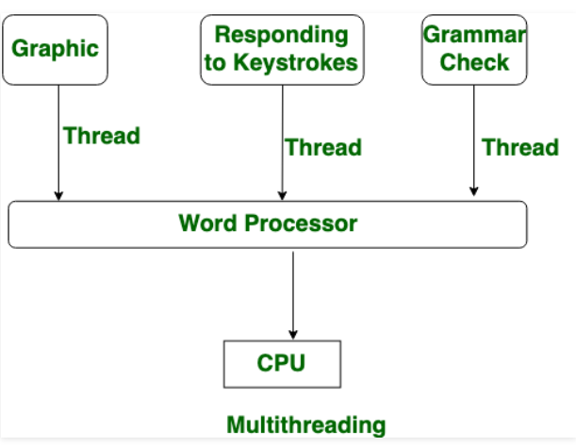

Multithreading is a framework wherein numerous strings are made from a procedure through which the PC power is expanded. In multithreading, CPU is given so as to execute numerous strings from a procedure at once, and in multithreading, process creation is performed by cost. Not at all like performing multiple tasks, multithreading gives a similar memory and assets to the procedures for execution.

Multithreading broadens the possibility of performing various tasks into applications, so you can partition explicit activities inside a solitary application into singular strings. Every one of the strings can run in equal. The OS isolates preparing time among various applications, yet in addition among each string inside an application.

In a multithreaded National Instruments LabVIEW program, a model application may be isolated into four strings - a UI string, an information procurement string, arrange correspondence, and a logging string. You can organize each of these with the goal that they work freely. Along these lines, in multithreaded applications, different undertakings can advance in corresponding with different applications that are running on the framework.

1. **Multi-tasking:**